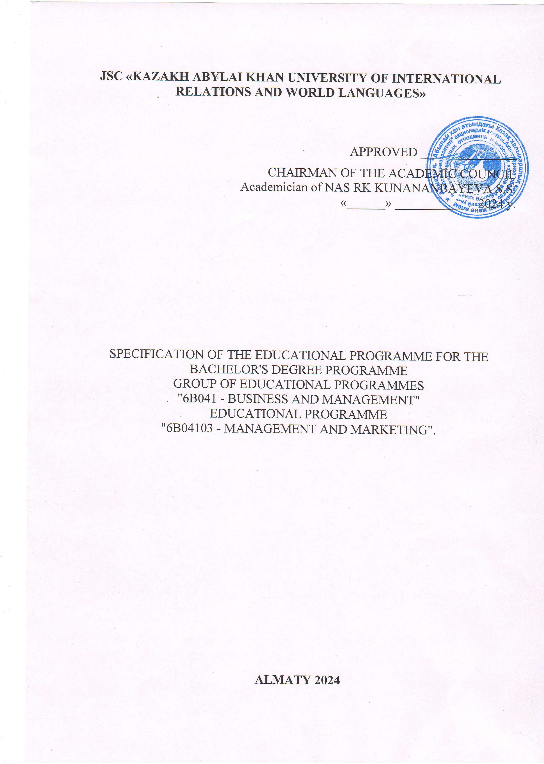

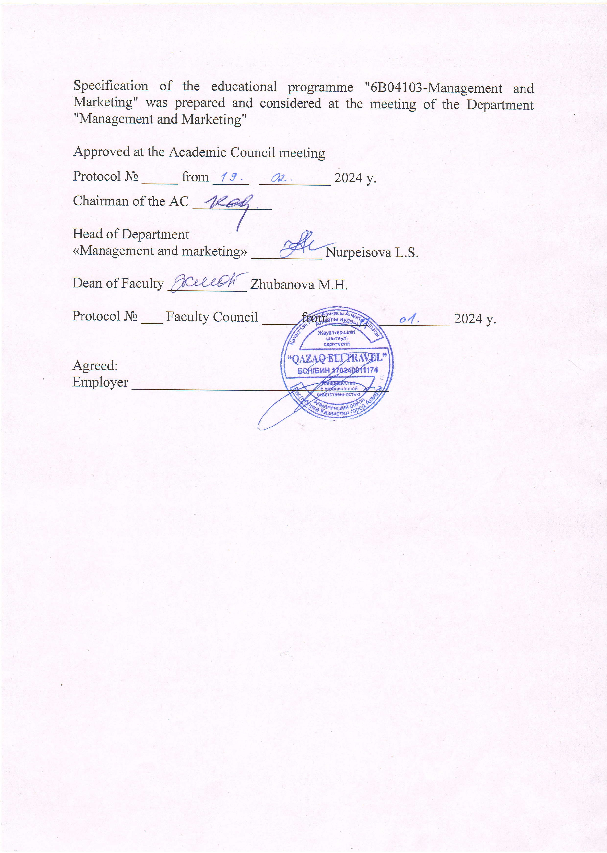

KAZAKH UNIVERSITY OF INTERNATIONAL RELATIONS AND WORLD LANGUAGES

Specification of the educational programme
"6B04103-Management and Marketing"
1. Code and classification of the field of education |  | 6B041- Business and Management
2. Code and classification of training areas |  | Educational Programme "6B04103 - Management and Marketing"
3. Degree awarded |  | Bachelor
4. Direction of training |  | Business and management
5. Qualification awarded |  | Bachelor of Business and Management in OP 6B04103 Management Marketing
6. Accreditation of the programme |  | Certificate NAAR AB 4817 from 16.06.2023
7. Study period |  | 4 years
8. Language of instruction |  | Kazakh/Russian
9. Faculty |  | "MANAGEMENT AND INTERNATIONAL COMMUNICATIONS"
10. Department |  | "Management and Marketing."
11. PROGRAMME PROFILE AND EDUCATIONAL OBJECTIVES
Purpose of the OP
The educational programme "6B04103 - Management and Marketing" is aimed at obtaining quality professional education, professional competence in the field of management and marketing, allowing to be in demand in practical activities in public and private enterprises and organisations of any sphere.
Programme Objectives:
- have knowledge of the laws of development of nature, society, thinking and the ability to apply this knowledge in professional activity;
- be able to analyse and evaluate socially significant phenomena, events and processes;
- demonstrate mastery of basic methods of quantitative analysis and modelling, theoretical and experimental research;
- have the ability to identify problems, define goals, and evaluate alternatives;
- choose the optimal decision option, evaluate the results and consequences of the made managerial and marketing decision;
- Have the ability to make decisions under conditions of uncertainty and risk;
- be able to apply adequate tools and technologies of regulatory impact in the implementation of management decision;
- be able to determine the quality parameters of marketing decisions and their realisations, identify deviations and take corrective measures.
According to the Atlas of New Professions, the prospects of the OP are as follows: manager, chief manager, manager-analyst, project manager, innovator, entrepreneur, marketer, goods promotion specialist, marketing analyst, marketing auditor, manager, commercial director, head of subdivisions of state management structures and enterprises of various forms of ownership.

12. Scope of study
- organisational and technological. Bachelor has all the skills for qualified work in the sphere of analytical, calculation and normative, consulting activities, development and application of management technology at a particular enterprise, including participation in the creation of scientific-methodological and organisational-technological base of management - together with other specialists develops and applies the most effective management methods, rules and procedures of strategic planning, personnel management, innovation management. Actively participates in the process of organising production, logistics and sales at the enterprise; - project. The bachelor carries out activities in two main areas: organisational design and feasibility study of projects. Organisational design includes the development of organisational management structures, their implementation, adaptation, development of innovations and identification of options for the development of management systems, as well as the analysis of economic projects, development and analysis of the effectiveness of specialised documents (feasibility study, business plan, etc.) relating to the organisation of a new enterprise or economic project, necessary for obtaining loans, credits and other types of financial support;
- production-management activity is the prerogative of bachelors in this speciality, as the educational process requires them to thoroughly study all issues related to the management process; including production management, creation of an effective system, application in practice of all known management principles, use of the developed scientific-methodological and organisational-technological base of management, implementation of the main management functions, analysis of the efficiency of their performance, control over the management of the production process. Bachelor carries out activities both within the framework of research programmes of higher educational institutions, and as a member of relevant research groups of research institutes, industrial enterprises and corporations or independently, a special place is given to international programmes of scientific cooperation in the field of economics, organisation, management; - educational or pedagogical activity of Bachelors of Management consists in professional activities in gymnasiums, colleges and lyceums; - commercial, in the field of management; - commercial, in the field of management; - commercial, in the field of management; - commercial, in the field of management.
__________________________________________________________________________________
13. TYPES OF PROFESSIONAL ACTIVITIES:
- Risk Management Manager
- Risk Analyst
- Innovation Development Manager
- Innovative marketing specialists
14. REQUIREMENTS FOR ADMISSION TO THE EDUCATIONAL PROGRAMME
Admission of applications for the OP "6B04103 - Management and Marketing" is held by the admission committee of the university from 20 June to 25 August.
For applicants entering the programme "6B04103 - Management and Marketing" on the basis of general secondary education, geography and foreign language are major subjects.
For applicants entering the OP "6B04103 - Management and Marketing" on the basis of technical and vocational education, the profile disciplines are "Geography" and "Mathematics".
Enrolment in the number of students is formalised by the order of the Rector of the University in the period from 10 to 25 August. The following students are enrolled on a paid basis for Bachelor's degree: graduates of general and secondary education organisations of the current year, who passed the UNT and scored at least 50 points according to the test results; graduates of previous years of general and secondary education organisations and graduates of technical and vocational education organisations.
15. EXPECTED LEARNING OUTCOMES
15.1 CC - MANDATORY COMPETENCES
OK1 | Able to collect, process and statistically analyse data necessary for solving the set economic tasks
OK2 | Able to critically evaluate options of managerial decisions to develop and justify proposals for their improvement taking into account criteria of socio-economic efficiency, risks and possible socio-economic consequences, to participate in the development of marketing activities of the organisation, to plan and implement measures aimed at its implementation
OK3 | Ability to use modern information technologies, manage information using business applications; use network computer technologies, databases and application software packages in their subject area.
OK4 | Able to analyse financial statements and apply financial tools to make effective management decisions to improve financial stability and reduce financial risks.
OK5 | Able to assess economic and social conditions of entrepreneurial activity and formulate a business idea
OK6 | Able to analyse micro- and macro-economic situations to make rational decisions in the course of his/her professional activity, analysing economic processes and phenomena and determining the degree of market impact at international and national level.
QA7 | To make decisions in the quality management system, to determine the order of work, to organise in subdivisions the work on improvement, modernisation, unification, manufactured products and their elements, on development of standardisation and certification projects, to ensure adaptation of modern quality management systems to specific conditions of production on the basis of international standards.
15.2 PC - PROFESSIONAL COMPETENCES
PC1 | Understands basic principles of economic functioning and economic development, goals and forms of government involvement in the economy.
PK2 | Able to participate in the development of human resource management strategy for organisations, plan and implement activities aimed at its implementation
PK3 | Able to develop business plans for the creation and development of new organisations (activities, products, etc.)
PK4 | Able to possess the methods of development and justification of strategic marketing decisions in various situations, theoretical and methodological bases of development and justification of strategic marketing decisions, as well as to have skills of development of marketing strategy of the enterprise and organisational development programme.
PK5 | Able to evaluate and apply various models and methods of marketing management system, its elements and principles in a competitive environment.
PK6 | Able to propose organisational and managerial solutions and assess the conditions and consequences of the decisions taken, justifying the results of solving strategic and operational management tasks both in general at the level of the organisation and its subdivisions, and in separate functional areas of management.
PK7 | Able to develop and implement optimal business strategies based on in-depth analysis of the external environment, generalisation of industry, micro- and macroeconomic trends - describe and model business processes of any complexity, carry out business restructuring and business process re-engineering.
15.3 LK - PERSONAL COMPETENCES OF GRADUATES
LC1 | Possess the basic values of world culture and readiness to rely on them in their professional activity, personal and general cultural development
LC2 | To possess a system of practical knowledge and skills providing acquisition, development, improvement and activation of physical abilities and qualities, acquisition, preservation and promotion of health, ability to work in a team, and to be guided by the principles of a healthy human lifestyle.
LC3 | Ability to earn the trust of others, have leadership skills in organising team activities and exercising professional management, demonstrate the ability to apply civil and criminal legislation in the field of economics, law, life safety and anti-corruption activities and research methods.
LC4 | Have an idea: about ethical and spiritual values; about sociological approaches to personality, basic regularities and forms of regulation of social behaviour; about the essence of power and political life, political relations and processes, about the role of political systems in the life of society and various social groups; about the role of consciousness and self-consciousness in the behaviour, communication and activity of people, formation and formation of personality
LC5 | Able to apply current international standards, specifications and technical reports used in the field of electronic records management and management information technologies
LK6 | Ability to professionally operate modern equipment, devices, network components, computer systems (in accordance with the objectives of the programme), as well as to use safety rules, industrial sanitation, fire safety and occupational health and safety standards.
LC7 | Able to determine the trajectory of self-development and self-education, to reflect on his/her own professional and personal capabilities.
15.3 ICC - INTERCULTURAL AND COMMUNICATION COMPETENCES
IAC1 | Ability to communicate in writing and orally in the state language and the language of interethnic communication; ability to build a logically correct, reasoned and clear oral and written speech; readiness to use one of the foreign languages
IAC2 | Ability to actually use the state language, language of interethnic communication in professional activities
IAC3 | Able to communicate in a foreign language, both orally and in writing, on professional topics; analyse social, professional and communicative problems in his/her professional activity.
IAC4 | Able to navigate in a foreign language environment, using language and information tools in general cultural and professional speech activities within the framework of the studied material
IAC5 | Able to communicate in the state, Russian and foreign languages to solve problems of interpersonal and intercultural interaction
IAC6 | Able to demonstrate mastery of the skills of logical and grammatically correct documentation in the state language and analyse information contained in scientific texts on the direction of training and conduct business communication in the state language.
IAC7 | Able to analyse situations in production, business production sites with all the resulting communicative tasks, to substantiate with evidence to solve various problems in professional activities in a foreign language.
16. LEARNING OUTCOME
RO1 | Possesses phonetic, grammatical and lexical skills in the foreign language sphere of communication, which requires comprehension, analysis, comparison and generalisation of information in a foreign language to express one's communicative intentions in solving professional tasks.
RO2 | Applies the main functional styles of the modern Kazakh (Russian) language and their linguistic features, as well as means and forms of language use in different conditions of communication, using the norms of business and oral speech for effective speech communication in the professional sphere when solving specific managerial and marketing tasks in a foreign language, on the basis of various etiquette formulas of official communication.
RO3 | Describes the behaviour of economic agents using categories and models, arguing their own views on contemporary microeconomic and macroeconomic phenomena to independently plan work with a focus on the final result related to work in the information space and analytical activities.
RO4 | Realises the obtained results, making responsible decisions in forecasting the main economic indicators of the enterprise's activity to carry out the collection and processing of data necessary for solving professional tasks related to theoretical, computational and experimental research methods, methods of mathematical and computer modelling in professional activities.
RO5 | Operates the assessment of resources and formation of entrepreneurial capital to run their own business, owning the methods of economic analysis of the firm and business, based on the determination of the level of entrepreneurial risks in order to manage and neutralise them.
RO6 | Uses practical marketing and management tools, methods and techniques in planning, organising and controlling marketing and management activities to conduct marketing research and reporting, in developing and implementing strategic plans, business, corporate and, functional strategies aimed at developing the organisation in the long term
RO7 | Draws up primary documents for recording business transactions in the implementation of accounting processes related to the financial activities of the company.
RO8 | Forecasts macroeconomic indicators of the development of the national and international economy and its economic entities to analyse the sectoral structure, raw material base of the country, region, industry, enterprise on the basis of determining the competitiveness of enterprises of various sectors of the economy
RO9 | Compiles questionnaires and conducts surveys, focus groups with the processing and analysis of statistical data to create recommendations in the organisation and conduct of advertising and PR-actions, personal sales, using methods of sales promotion and direct marketing.
RO10. | Applies modern tools, methods and technologies of Event-marketing, branding, Internet advertising and SocialMediaMarketing, word of mouth marketing, taking non-standard and creative advertising solutions for effective and low-cost promotion of goods and services in the market.
RO11 | Use modern technologies in the field of digital management and marketing in solving typical tasks in the field of professional activity related to the use of innovative and information technologies to solve management problems and is able to understand the principles of digital technologies.
RO12. | Determine the system of material and moral incentives in increasing the interest of employees in the results of work, career growth and personal development, influencing the behaviour of individuals, groups in the organisation through various methods and mechanisms for clear distribution of workload and control of its implementation.
RO13 | Collects and interprets information on government orders, benefits, subsidies and other instruments of state support of business in the effective allocation of material, financial, labour, scientific and technical resources, implementing the quality management system to make optimal management decisions related to the production activities of the enterprise.
RO14. | Implements in practice the tools of crisis management to crisis diagnostics on the basis of the principles of development of anti-crisis strategy of the organisation, methods and tools of Lean-management as a basis of lean production, modelling business processes, technologies of improvement of business processes for monitoring and calculation of their indicators.
RO15. | Operates the basic principles and tools for strategic management in modern conditions, to analyse the criteria of strategic production policy of the organisation (enterprise) on the basis of strategic management of strategic marketing decisions methods of creating a management marketing system in the organisation.
17. CONTENT OF THE EDUCATIONAL PROGRAMME
17.1 OVERALL PROGRAMME STRUCTURE
The study programme is usually designed for four academic years of study. The academic year is divided into 2 semesters of 15 weeks each. The programme is taught on a modular basis. 1 module usually consists of 7-9 credits. During one semester the study load of a student can not exceed 3-4 modules. Final state certification of students is held in the form of defence of professional-applied project.

17.2 MODULES OF THE EDUCATIONAL PROGRAMME
17.2.1 General Education Module
I General Education Block of the Curriculum (GEBP)
I Vocationally oriented training modules
Module 1.1. Module Social and attitudinal module |  | Acad. credits | Exam / semester
OOD OK | History of Kazakhstan  The course is aimed at providing students with objective historical knowledge of the main stages of the history of modern Kazakhstan, the establishment and development of independent statehood in Kazakhstan, spiritual culture, continuity and continuity of ethnogenesis; to bring to the consciousness of students the essence of fundamental problems of history, to teach scientific methods of historical cognition, to form a scientific worldview and civic attitude | 5 | 1 (GE)
OOD OK | Philosophy  The course is aimed at studying the updated content of the general education discipline "Philosophy", studying the necessary knowledge on the main problems and achievements in the field of philosophy and its main sections (ontology, anthropology, etc.), developing interest in fundamental knowledge and skills of systematic analysis and evaluation of events and facts of reality, formation of students' openness of consciousness, understanding of their own national code, mastering the key worldview concepts (justice, dignity and freedom), as well as the development and learning of the key worldview concepts (justice, dignity and freedom). | 5 | 4
OOD VC | Basics of personal development  This discipline is aimed at studying and researching the issues of formation of personal development of students for personal growth and development of students' knowledge of economics and law, anti-corruption culture, ecology and life safety, as well as entrepreneurial skills, leadership, receptivity to innovation, as well as the issues of successful implementation of their career and personal potential in labour and, possibly, scientific activity. | 6 | 3
 | Bottom line: | 16

Module 1.2 Physical Education
OOD OK | Physical Education | 8 | 1,2,3,4
 | Bottom line: | 8
Module 1.3 Social and Political Knowledge
OOD OK | Sociology  The course is aimed at forming in students the basics of sociology and political science, contributing to the training of educated, creatively thinking specialists, who possess the categorical and conceptual apparatus in the field of sociology and political science, having a correct representation of the existing forms and types of social and political system.  Political Science  The political science course is designed to introduce students to the basics of political science and to form a general idea of politics, its main aspects, problems, regularities and interaction with other spheres of social life. | 2 | 3
 |  | 2
OOD OK | Cultural studies  The course is aimed at forming in students a scientific idea of human nature, manifested in its various forms, at studying the nature of interaction of cultures and trends of world cultural universalisation, peculiarities of development of cultural studies in Kazakhstan, assimilation of factors and mechanisms of cultural socialisation of personality.  Psychology  The course is aimed at forming in students a system of knowledge on those sections of psychology, which are necessary for making informed decisions in managerial activity. | 2 | 3
 |  | 2
 | Bottom line: | 8
Module 1.4 General Language Module
OOD OK | Foreign language (English)  The course programme is aimed at developing students' foreign language communicative competence: the ability and willingness to communicate orally and in writing in social, domestic and academic spheres, as well as mastering the basics of terminology of the relevant area of training. | 10 | 1,2
OOD OK | Kazakh (Russian) language  The course programme is aimed at forming a modern linguistic personality, improving the general speech culture of students, mastery of the state language | 10 | 1,2
 | Bottom line: | 20

Module 1.5 Digitalisation
OOD OK | Information and Communication Technologies The course programme is aimed at the use of information and communication technologies/ICTs in professional activities in English language | 5 | 2
 | Bottom line: | 5
 | Total OOD OK  Vocationally orientated training modules: | 57

II. Basic Block of the Curriculum (BBUP)
II. Vocationally based training modules
Module 2.1 Modern models and theories of economic development
VC DATABASE | Economic theory  The course is aimed at the study by students of the issues of performance of certain types of activities, based on fundamental knowledge of concepts and categories of modern economic theory, regularities of functioning of the market economy and behaviour of its subjects, mechanisms of formation of prices and production volumes on different types of markets, interrelation and dynamics of national production volumes, inflation, employment and other macroeconomic aggregates; to form a methodological basis for the study of special theoretical courses of the programme. | 5 | 1
CV DB | Microeconomics  This course teaches future specialists theoretical knowledge of microeconomic aspects of functioning and development of modern economy, as well as related to practical skills in the field of microeconomic analysis and other modern scientific means of research of microeconomic processes, provides students with a system of knowledge of microeconomics as one of the fundamental disciplines used in the study of other economic subjects. | 5 | 2
CV DB | Macroeconomics  The discipline is aimed at the formation of knowledge about macroeconomics as an integral system, studying the functioning and development of the national economy of the country, analysing the most urgent problems of the economy, the impact of the economic policy of the state on the economic life of society and provides for students to master the basic regularities and trends of the economic system, forms an idea of the main forms and types of organisational structure, giving students the skills to analyse situations in the market of goods and resources. | 4 | 2
 | Bottom line: | 14
Module 2.2 Financial and Accounting Basis for Business Operations
CV DB | Fundamentals of accounting  The process of studying the discipline is aimed at understanding the methodology of accounting, the legality of business operations. This discipline involves consideration of the basis and structure of accounting, the study of financial and economic activities, the conduct of operations on calculations, the formation of the results of activities and their analysis, the preparation of financial statements at enterprises. | 4 | 3
CV DB | Fundamentals of finance  This course presents the main aspects of finance: theoretical foundations, forms of organisation, practical application of finance, from different positions of the economic category, its role and importance in reproduction processes and socio-economic development of society. | 4 | 4
 | Bottom line: | 8
VC DATABASE | Training practice  The course programme is aimed at the implementation of the acquired methods and skills, technology of business diplomatic communication in the conditions of real professional communication familiarisation with your future profession and acquisition of primary professional experience. | 3 | 4
 | Bottom line: | 3
Module 2.3 Professional Oriented Language Module
VC DATABASE | Professionally oriented foreign language  Formation of foreign-language professionally oriented communication of students in the sphere of marketing and management, allowing them to integrate into the international professional environment and use professional English as a means of intercultural and professional communication. | 12 | 3,4
VC DATABASE | Business administration and business communication in the State language  This course forms students' intercultural communication, gives them tools for adequate professional communication in the sphere of their activity. The ultimate goal of the course is to master the skills of business communication on the basis of the language of speciality, to improve the professional training of students. | 3 | 4
VC DATABASE | Professional communicative situational workshop  The main purpose of this course is to form communication in students, i.e. practical mastery of basic professional terminology, its active application in the discussion of practice-oriented situational tasks related to the field of marketing and management. | 3 | 4
 | Bottom line: | 18
Module 2.4 Entrepreneurship
CV DB | Entrepreneurial activity  The course is directed on studying and formation of normative-legal, economic and organisational knowledge and skills on questions of formation, the organisation and conducting of business activity in conditions of the Kazakhstan economy, and also reception of system representations about bases of the organisation of own business, development of organisational and administrative skills of conducting business activity. | 4 | 1
CV DB | Business planning in the hospitality industry  The course is oriented to familiarise students with the scientific approach of studying and mastering the knowledge and understanding of the basic principles and methods of business planning, basic skills to apply the methods and technologies of business planning in practice in the activities of enterprises of the hospitality industry. | 4 | 1
CV DB | Innovative business development  The course is aimed at a comprehensive understanding of innovative business development, peculiarities of planning and organisation of innovative activity of the enterprise, methods of research and development management, allowing the effective functioning of the enterprise, as well as to study the main forms of business financing in order to make investment in risky innovations. | 4 | 2
 | Bottom line: | 12
Module 2.5 Theoretical and practical foundations of management and marketing
VC DATABASE | Fundamentals of management  This course forms at students system, professional skills and skills of management in business on the basis of application of modern principles, methods and approaches of management, acquiring at students skills of formation of the most effective variants of structure of management system in organisations, enterprises, as well as functioning, development of their basic functions of management (organisation, planning, motivation, control) and acceptance of operative, effective management decisions. | 5 | 3
VC DATABASE | Marketing basics  The course is aimed at formation of theoretical, professional skills and skills of marketing activity management on the basis of application of modern marketing technologies, mastering of modern marketing concepts, basics of marketing activity management in innovative sphere, acquisition of skills of marketing management decision making through the system of knowledge about regularities and laws of marketing, which constitute the structure of marketing activity in the market. | 4 | 4
 | Bottom line: | 9
Module 2.6 Standardisation of quality of goods and services
CV DB | Expertise of goods and services  The course is aimed at forming in students a system of theoretical knowledge in the field of expertise of goods and services, practical understanding of the establishment of conformity of goods and services to the requirements of technical regulations and normative acts, determining the order of organisation and preparation of decision-making on the examination of goods and services, studying the organisational structure of subjects of expertise of goods and services, mastering the means and methods of examination and documentation of expert evaluation of goods and services. | 4 | 5
Bottom line: |  | 4
Module 2.7 Economic Analysis of Enterprise Performance
VC DATABASE | Business economics  This course examines the problems of functioning of enterprises in a market economy; in the course of study the student analyses the main aspects of economic activity; studies the main technical and economic indicators of the enterprise and its structural units; chooses the directions of effective use of material, labour and financial resources of enterprises. | 5 | 6
VC DATABASE | Economics of trade  The content of the course allows students to understand the essence and importance of trade, to form knowledge of trade turnover, proceeds from sales realisation and to operate freely with economic indicators of wholesale and retail trade. Students will become familiar with the forms and methods of wholesale and retail trade at enterprises in countries with developed market economies, as well as acquire skills in the methods of analysing the activities of trade enterprises. | 5 | 5
Bottom line: |  | 10
Module 2.8 Professional and Communicative Language Module
VC DATABASE | Foreign language in business and management  The foreign language course aims to form a foreign language thesaurus in the field of business and management, provides students with tools in the field of modern methods of business management, prepares them for discussions in this area and analysis of texts of managerial discourse. | 12 | 5,6
VC DATABASE | Specialised Foreign Language in Business and Management  The course develops the communicative-intercultural and professional aspect of foreign language skills, uses speech components, concepts and terminology of the speciality in a foreign language, aims at comparing language clichés in professional situations. | 6 | 7
PD VK | Professional-communicative language workshop  The course prepares for oral communication in the main situations of a professional foreign language. The student has the opportunity to communicate in a foreign language on given topics, relying on linguistic and textual material, summarises information and constructs statements. | 9 | 5,6,7
VC DATABASE | Industrial practice  Industrial practice is aimed at consolidation of theoretical knowledge obtained in the process of study, acquisition of practical skills and experience of professional activity in the conditions of the organisation. | 3 | 6
 | Bottom line: | 30
Digital Enterprise Management (Minor)
CV DB | Digitalisation of professional activity (marketing analyst)  The course is aimed at considering new digital technologies of systematisation, storage and analysis of management information, their advantages in comparison with traditional methods of information support of marketing and improvement of results of marketing consequences. | 3 | 6
CV DB | Marketing audit  The course considers the fundamental directions of studying the theoretical marketing bases of business audit of the formation and application of marketing audit in companies. The objectives of the discipline are to consider throughout the course the idea of the role and purpose of marketing audit, the fundamental principles of audit in modern conditions. Students receive theoretical and practical tools for organising the accounting process in organisations and developing a standard on marketing audit and its implementation in the Chamber of Auditors of the Republic of Kazakhstan. | 6
Bottom line: |  | 9
Total DB  Vocational Identification Training Modules |  | 112
DISCIPLINE CYCLE
III. Vocational Identification Training Modules
Module 3.1 State regulation of economy and business
PD VK | State regulation of the economy  Within the framework of the discipline students receive theoretical knowledge and practical skills on issues related to the forms and methods of state participation in the economic life of the country through various levers of influence on socio-economic processes, ensuring the effective formation of market relations. | 4 | 5
PD TOR | Instruments for regulating the activities of business entities  This course is aimed at providing theoretical and practical application of methods and tools to regulate the activities of business entities, these include the science of taxes as a specialised section of financial science, tools to regulate the activities of business entities, the science of taxes, the doctrine of finance and the state, the theoretical basis of knowledge of the essence of taxes and the mechanism of taxation. The necessity of studying taxes and their organisation. The importance of historical and logical approaches in the study of the system of taxation of business entities and the population. | 4 | 5
 | Bottom line: | 8
Module 3.2 Ethics and Governance Module
CV DB | Ethics and psychology in management  The course is aimed at the formation of psychological knowledge and skills necessary for professional activity, future specialists in the field of management will receive a tool for diagnosing and forecasting the state of people, programming the process of conflict management, effective communication with employees, the application of psychological principles of motivation of employees and creating conditions for effective work. | 4 | 5
PD TOR | Personnel management  During the study of the course practical skills and abilities in professional selection of personnel and use of situational approach in their selection, development of the ability to analyse organisational problems through the prism of the human factor and development of managerial decisions to improve the use of human resources in business, improving the system and processes of personnel management are formed. | 4 | 6
 | Bottom line: | 8
Business Process Management (Minor)
PD TOR | Business process forecasting  This course deals with the process of company management, management of production, marketing, innovation, human resources and financial spheres of the enterprise on the basis of process management methodology, as well as a systematic methodological approach to project activities. | 4 | 7
PD TOR | Business process analysis  During the course, students consider the application of the main tools of micro and macroeconomic analysis in business; develop an understanding and interpretation of micro and macroeconomic policies based on a specific economic situation, analysing supply and demand markets and economic trends in the economy. | 5
 | Bottom line: | 9
Module 3.3 Organisation Management
PD TOR | Crisis management  The course is aimed at providing students with a comprehensive understanding of the principles and methods of crisis management aimed at balancing the interests of the company, its contractors, employees, society and the state. The study of this course will allow students to familiarise themselves with the economic, legal and methodological foundations for the implementation of the functions of a crisis manager, to understand the role and tasks of state management bodies in the regulation of crisis situations. | 4 | 7
PD TOR | Lean management  The course is aimed at acquiring theoretical knowledge and practical skills in the field of making managerial decisions related to production (operational) activities of the enterprise. The course considers the role and place of the enterprise as an independent economic entity in the system of market relations; - clarification of regularities of industrial production development in the conditions of advanced technologies and automation of production processes; - study of methods of rational organisation of production processes, as well as methods of the most efficient use of production resources of the enterprise | 4 | 7
PD VK | Strategic management  The course is aimed at learning the basics of the theory and practice of strategic management as a promising direction for the development of systems in a highly variable environment. It contributes to the formation of students' strategic thinking necessary for successful work in business. Throughout the course, the student analyses a selected company (existing or planned to be created for the implementation of a specific start-up project) and uses it as an example to develop skills in applying the methods of strategic analysis and developing a corporate strategy and a roadmap for its implementation. | 6 | 8
 | Bottom line: | 14
Module 3.4 Marketing Strategy of the Organisation
PD TOR | Integrated marketing communications  Within the framework of this course, students consider systematic methods in the development of marketing communication campaign strategies and individual stages of their tactical implementation, taking into account trends in consumer behaviour, competitive environment, marketing objectives and embedded brand identity. In the process of studying the discipline the student learns the peculiarities of marketing communications, the relationship between advertising and other means of marketing communications, acquiring skills to build a campaign to promote goods and services on the market. | 4 | 7
PD VK | Strategic marketing  This course reflects modern principles and scientific developments in strategic marketing in business management and provides a comprehensive study of the processes and methods of marketing research and corporate management of companies and enterprises. The course builds students' skills to understand, analyse and implement international marketing operations, apply various research methods in analysing data for subsequent decision-making in marketing management and to ensure effective development, stable profitability and sustainability of enterprises, assess the prospects and current trends in international corporate governance practices in the field of business. | 5 | 8
PD TOR | Marketing research  Within the framework of this course an understanding of the methodology of marketing research, the main directions and types of research, methods of collecting, processing and analysing marketing information to reduce uncertainty in making marketing decisions necessary for professional activity is formed. | 5 | 8
 | Bottom line: | 14
PD VK | Industrial/pre-diploma practice  The purpose of pre-diploma practice is to prepare a final qualification work and fulfil professional and creative duties | 6 | 8
 | Bottom line: | 6
Total number of PDs  Vocational Identification Training Modules |  | 64
Final Attestation:  1.Writing and defence of a thesis (project) or  2. Preparing and taking 2 comprehensive examinations:  Comprehensive Exam 1:  1.1 Fundamentals of marketing  1.2 Fundamentals of management  1.3 Integrated marketing communications  Comprehensive Exam 2:  Business Process Management (Maynor)  3. Preparing and taking an exam in professional ILE |  | 8 | 8
 | Bottom line: | 8
TOTAL by OP |  | 241

16.3 SCHEMA FOR SHAPING LEARNING OUTCOMES
PROFESSIONAL COMPETENCES
II. Vocationally based training modules
NAME  MODULE | OK1 | OK 2 | OK 3 | OK 4 | OK 5 | OK 6 | OK 7
Module 2.1 Modern models and theories of economic development |  |  |  |  |  | X
Module 2.2 Financial and Accounting Basis for Business Operations |  |  |  | X
Module 2.4 Entrepreneurship |  |  |  |  | X
Module 2.5 Theoretical and practical foundations of management and marketing |  | X
Module 2.6 Standardisation of quality of goods and services |  |  |  |  |  |  | X
Module 2.7 Economic Analysis of Enterprise Performance | X
Managing the digital enterprise |  |  | X

PROFESSIONAL COMPETENCES
MODULE NAME | PC1 | PC 2 | PC 3 | PC 4 | PC 5 | PC 6 | PC 7
Module 3.1 State regulation of economy and business | Х
Module 3.2 Ethics and Governance Module |  | Х
Business Process Management (Minor) |  |  | Х |  |  |  | Х
Module 3.3 Organisation Management |  |  |  |  |  | Х
Module 3.4 Marketing Strategy of the Organisation |  |  |  | Х | Х

PERSONAL COMPETENCES
 | LC1 | LC2 | LC3 | LC4 | LC5 | LK6 | LC7
Module 1.1. Social and attitudinal module |  |  | Х |  |  |  | Х
Module 1.2. Physical culture |  | Х
Module 1.3. Socio-political knowledge | Х |  |  | Х
Module 1.5 Digitalisation |  |  |  |  | Х | Х
INTERCULTURAL COMPETENCES
 | IAC1 | IAC 2 | IAC 3 | IAC 4 | IAC 5 | IAC 6 | IAC 7
Module 1.4 General Language Module | Х |  |  |  |  | Х
Module 2.3 Professional Oriented Language Module |  | X |  | X
Module 2.8 Professional and Communicative  Language Practicum |  |  | X |  | X |  | X

17. INTERNATIONAL ACADEMIC MOBILITY WITHIN THE FRAMEWORK OF THE EDUCATIONAL PROGRAMME
- University of Fribourg (Switzerland)
- IULM (Italy)
- Artevelde University of Applied Sciences (Belgium)
18 Educational programme "6B04103 - MANAGEMENT AND MARKETING"
includes the following types of professional practices:

- pre-diploma course - 6 credits
- industrial - 3 credits
- academic - 3 credits

19.1 TRAINING PRACTICE
The purpose of training practice is to obtain knowledge, primary professional skills and skills necessary to perform work in the field of management and marketing; systematisation, consolidation and expansion of theoretical and practical knowledge obtained by students during training.

Objectives of the training practice:
-reinforcement, deepening and expansion of theoretical knowledge, skills and abilities acquired by students in the process of theoretical training;
- realisation of motives and values in the chosen profession;
-learning the essence and content of the legal foundations of managerial and marketing activity in the conditions of modern market economy;
-acquaintance with the nature of activity of organisations and enterprises, prospects of their development, peculiarities of the organisation of the marketing process;
-development of skills in searching for necessary normative legal acts, their interpretation and use in professional activities;
-study of the principles of organisational and production structure of the enterprise, rational organisation of the production process, management of marketing activities;
-study of the functioning of the organisation's internal document management system, maintenance of databases on various indicators and formation of information support for participants of organisational projects.
Venue:
1 Golden Sharks LLP
2 TechnoGRAD LLP
3 Kazakhtelecom JSC
4 JSC Home credit bank
5 TOO "FARAOIL-GROUP"
6 Ministry of Trade and Integration of the Republic of Kazakhstan
19.2 INDUSTRIAL PRACTICE
The purpose of industrial practice is systematisation, generalisation and deepening of theoretical knowledge, formation of practical skills, general cultural, professional competences and professional competences of the profile on the basis of studying the work of organisations in which students undergo practice.

The objectives of the industrial practice are:
- mastering professional skills of working and solving practical problems;
-gain practical experience of working in a team;
-collection of materials for the fulfilment of the practice report;
-Research and analysis of external and internal conditions of the company's activity, specifics of business and peculiarities of the management system;
-acquaintance with legal, regulatory, organisational and administrative documents and internal standards and other documents that the company is guided by in carrying out its activities;
-acquaintance, study and practical mastering of the main directions of management and marketing activities in the organisation;
-acquisition and consolidation of new skills in the field of organisation management system necessary for formation of a management specialist demanded by the employer;
-Preparation of a written report on the results of the internship.
Venue:
1 Kazakhtelecom JSC
2 Zhazushy Publishing House LLP
3 TOO "ANCON
4 JSC Home credit bank
5 Lotte Rakhat JSC
6 IP "Asia"
19.3 INDUSTRIAL (PRE-DIPLOMA) PRACTICE
Purpose of industrial (pre-diploma) practice:
Industrial (pre-diploma) practice is aimed at deepening the initial practical experience of the student, development of general and professional competencies, testing his readiness for independent labour activity, as well as preparation for the implementation of professional and applied project in organisations of various organisational and legal forms.

Tasks of industrial (pre-diploma) practice:
- development of student's abilities for independent activity in the sphere of management: organisational, analytical, communicative, research, self-organisation and self-control;
-acquaintance with normative, legislative acts and materials, instructions, methodological recommendations and other documents that guide organisations in their activities when carrying out marketing activities and project management in different areas and at different levels;
- studying and analysing the management system and marketing activities of the enterprise;
-development of proposals to improve the areas of activity of the manager of the lower and middle levels of management in the organisation;
Formation and development of professionally significant qualities in students, sustainable interest in professional management activity, the need for self-education; - Collection of necessary materials and documents for the final qualification work in accordance with the chosen topic.
- acquiring skills and abilities of managerial, organisational and marketing work;

Venue:
1.Magnum Cash & Carry LLP
2. 360 PRODUCTION LTD.
3.AlmaTel Kazakhstan JSC
4.Eurasian Trading System Commodity Exchange JSC
5.Astana ITI Group LLP
6.AK Altynalmas JSC

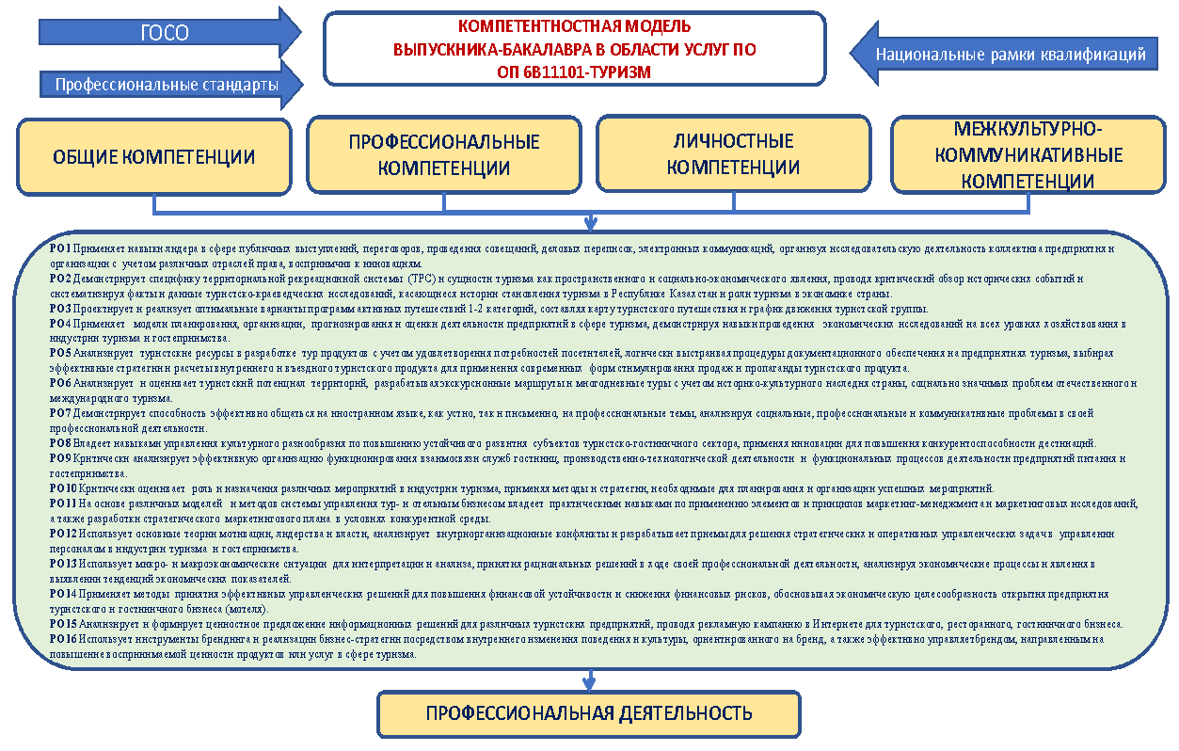
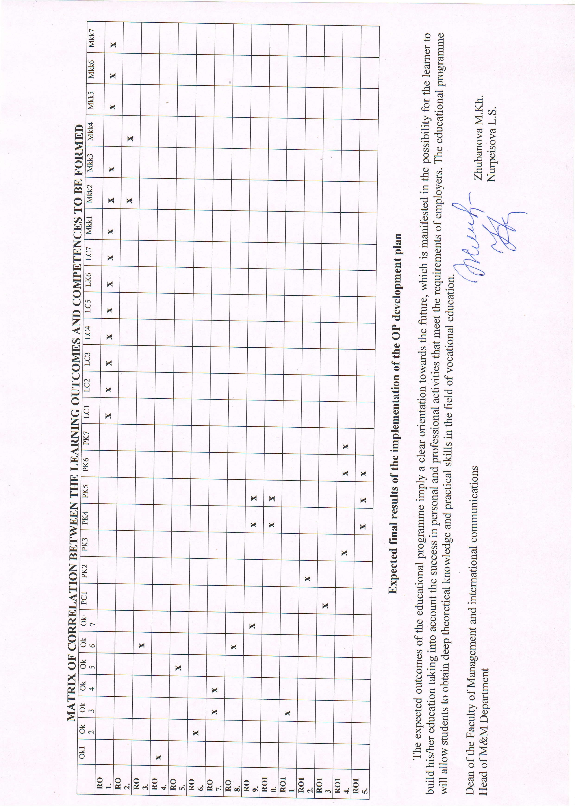
COMPETENCY-BASED MODEL
BACHELOR'S DEGREE IN BUSINESS AND MANAGEMENT
ЕP 6V04103-MANAGEMENT AND MARKETING
RO Possesses phonetic, grammatical and lexical skills in the foreign language sphere of communication, which requires comprehension, analysis, comparison and generalisation of information in a foreign language to express one's communicative intentions in solving professional tasks.
RO 2 Applies the main functional styles of the modern Kazakh (Russian) language and their linguistic features, as well as the means and forms of language use in different communication conditions, using the norms of business and oral speech for effective speech communication in the professional sphere when solving specific managerial and marketing tasks in a foreign language, on the basis of various etiquette formulas of official communication.RO 3 Describes the behaviour of economic agents using categories and models, arguing their own views on the current state of affairs in the Kazakh (Russian) language.
RO 4 Realises the obtained results, making responsible decisions in forecasting the main economic indicators of the enterprise's activity to carry out the collection and processing of data necessary for solving professional tasks related to theoretical, computational and experimental research methods, methods of mathematical and computer modelling in professional activities.
RO 5 Operates the assessment of resources and formation of entrepreneurial capital to run their own business, knowing the methods of economic analysis of the firm and business activities, based on the determination of the level of entrepreneurial risks in order to manage and neutralise them.
RO 6 Uses practical marketing and management tools, methods and techniques in planning, organising and controlling marketing and management activities to conduct marketing research and reporting, in developing and implementing strategic plans, business, corporate and, functional strategies aimed at the development of the organisation in the long term.
RO 7 Compiles primary documents for recording business transactions in the implementation of accounting processes related to the company's financial activities.
RO 8 Forecasts macroeconomic indicators of the development of the national and international economy and its economic entities to analyse the sectoral structure, raw material base of the country, region, industry, enterprise on the basis of determining the competitiveness of enterprises in various sectors of the economy
RO 9 Compiles questionnaires and conducts surveys, focus groups with the processing and analysis of statistical data to create recommendations in the organisation and conduct of advertising and PR-actions, personal sales, using methods of sales promotion and direct marketing.
RO 10 Applies modern tools, methods and technologies of Event marketing, branding, Internet advertising and SocialMediaMarketing, word of mouth marketing, adopting non-standard and creative advertising solutions for effective and low-cost promotion of goods and services in the market.
RO 11 Use modern technologies in the field of digital management and marketing in solving typical tasks in the field of professional activity related to the use of innovative and information technologies to solve management problems and is able to understand the principles of digital technologies.
RO 12 Determine the system of material and moral incentives in increasing the interest of employees in work results, career growth and personal development, influencing the behaviour of individuals, groups in the organisation through various methods and mechanisms for clear distribution of workload and control of its implementation.
RO 13 Collects and interprets information on government orders, benefits, subsidies and other instruments of state support of business in the effective allocation of material, financial, labour, scientific and technical resources, implementing the quality management system to make optimal management decisions related to the production activities of the enterprise.
RO 14 Implement in practice the tools of crisis management to diagnose crises based on the principles of crisis management strategy development, methods and tools of Lean management as a basis for lean production, modelling business processes, business process improvement technologies for monitoring and calculation of their indicators.
RO 15 Operates the basic principles and tools for strategic management in modern conditions, to analyse the criteria of strategic production policy of the organisation (enterprise) on the basis of strategic management of strategic marketing decisions methods of creating a management marketing system in the organisation.

